CIRCULAR LOG CABIN
BUCK-A-BLOCK 2025-2026
This will be a 12.5” unfinished block that finishes to a 12” block. There is a layout of the block on page 2. The block should be worked in a counter-clockwise manner.
One half of the block should be white-on-white fabric. This will use 1.5” wide strips cut into various lengths. The other half of the block is up to you. This will require 2.5” wide strips cut into various lengths. See chart on page 3.
You may choose your own color scheme and arrangement for the colored half. Solids or prints, brights or pastels, reproductions, novelties are all acceptable. I have attached some examples of different log arrangements on page 4. Do not be limited by my efforts. Some quilt layout examples are included in a separate file.
The most requested blocks from the last quilt show included Christmas and purple fabrics. However, almost all the blocks were sold. Some additional ideas might include other holiday-themed blocks (Valentine’s Day, Easter, Memorial Day/4th of July, Thanksgiving), masculine, juvenile.
No kits will be provided this year. Susan will bring her Accuquilt cutter to the Thursday segment of the quilt retreat for the 1.5” strips.
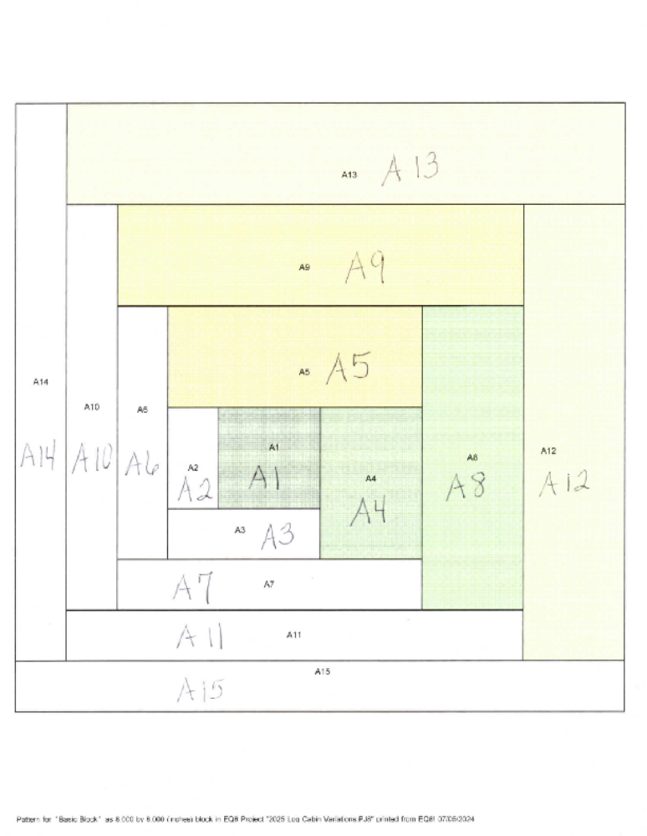

White-on-White  1.5 “ width |  |  | Colored 2.5” width
Segment | Length |  | Segment | Length
A2 | 2.5” |  | A1 | 2.5”
A3 | 3.5” |  | A4 | 3.5”
A6 | 5.5” |  | A5 | 5.5”
A7 | 6.5” |  | A8 | 6.5”
A10 | 8.5” |  | A9 | 8.5”
A11 | 9.5” |  | A12 | 9.5”
A14 | 11.5” |  | A13 | 11.5”
A15 | 12.5”



